**#FunTimesWithTheTA   
Firefly – a “Do-It-Yourself” Blinky Charm**

Adapted from: Blinky Board by Orlando S. Hoilett

**Introduction**

In this installment of #FunTimesWithTheTA we will build Firefly a “Do-It-Yourself” Blinky Charm. For Firefly we will build a circuit that cyclically turns a set of LEDs on and off.

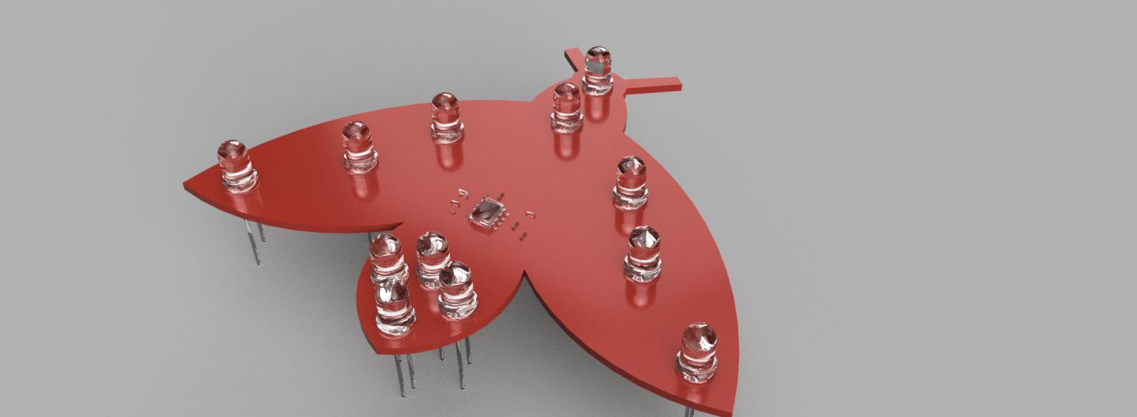

*Figure 1: 3D Render of Firefly PCB.*

**Objectives**

* Understand the use of capacitors to hold and discharge voltage
* Understand the application of time constant to different circuit configurations
* ***Have some FUN! FUN! FUN!***

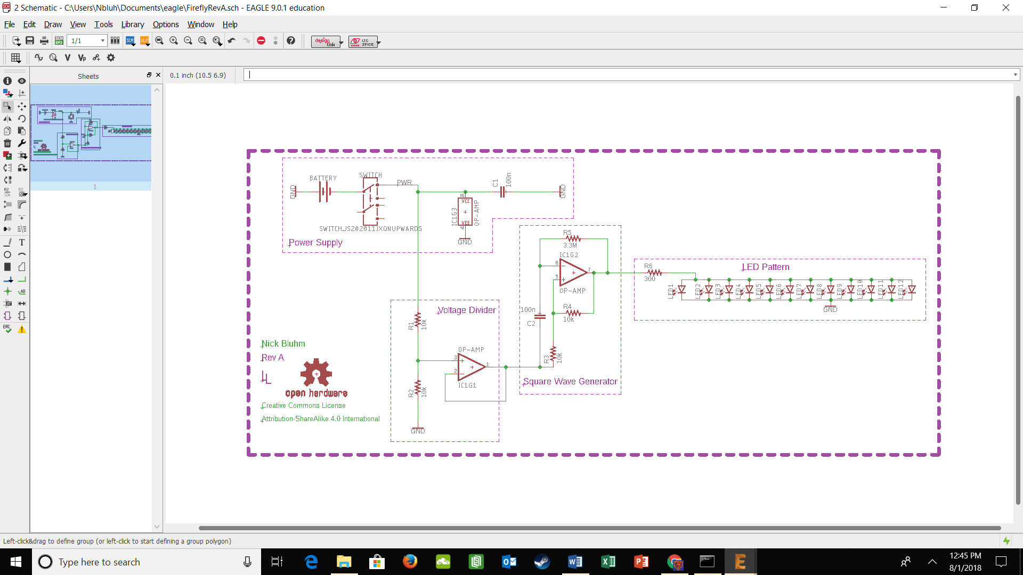

*Figure 2: Circuit diagram of Firefly.*

**Table of Contents**

|  |  |
| --- | --- |
| **Section** | **Page** |
| Introduction | **1** |
| Objectives | **1** |
| #Firefly Schematic | **1** |
| Part #1: Power Supply | **2** |
| Part #2: Voltage Divider | **3** |
| Part #3: Square Wave Generator | **4** |
| Part #4: LED Pattern | **6** |
| Part #5: Soldering the PCB | **7** |
| Revision History | **9** |

**Part #1: Power Supply**

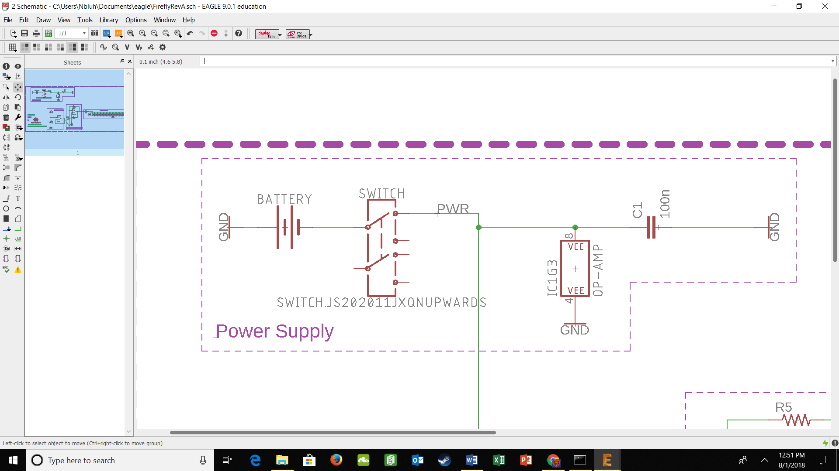

*Figure 3: Power Supply.*

The power is supplied to this circuit by a battery (BATTERY). The circuit is turned on and off by using a switch (SWITCH). When the switch is closed, there is a compete circuit and the circuit is powered. When the switch is open, there is a break in the circuit and no current can flow, leaving the circuit without power. (OP-AMP) pictured here represents the power pins of the operation amplifier. The positive power pin is connected to the battery and a bypass capacitor (C1), which helps reduce noise drawn from the power source. The negative power pin of the operation amplifier is connected to ground.

***Instructions***

1. Place all of the components into a breadboard
2. A switch is not necessary for the breadboarding, it will be necessary when soldering together the final PCB

***Testing:***

1. Verify that all the connections are made by checking for continuity

**Part #2: Voltage Divider**

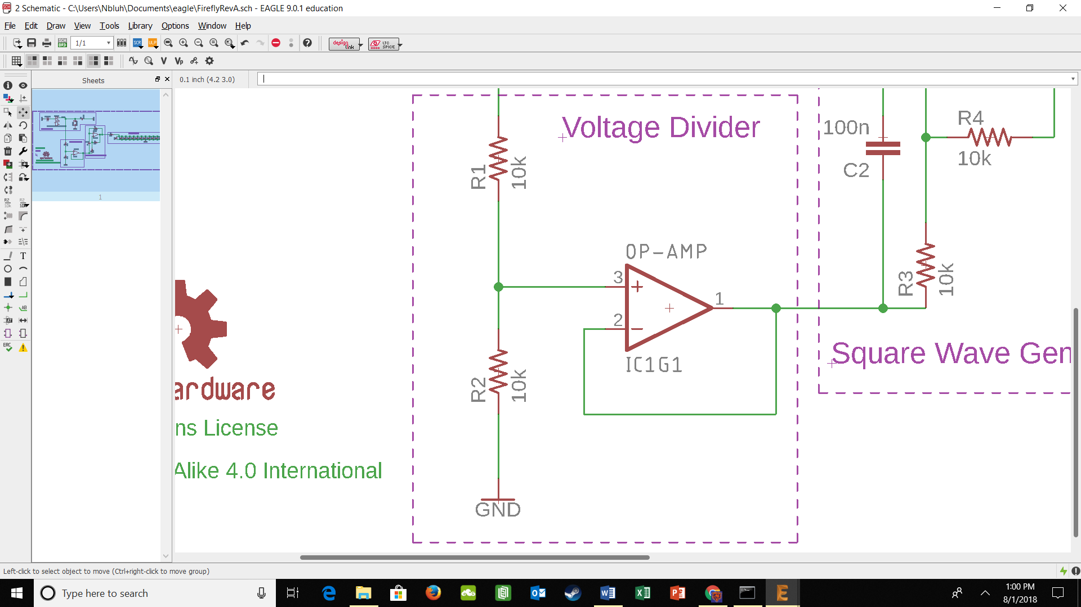*Figure 4: Voltage Divider.*

A voltage divider is a convenient way to alter the voltage from a standard supply to a more appropriate voltage for a given task. In this instance we are dividing the voltage in half by using the same resistance for the top and bottom resistors. For more on voltage dividers check out <https://learn.sparkfun.com/tutorials/voltage-dividers>. The equation that defines voltage dividers is

$$V_{out}= V_{in}* \frac{R_{2}}{R_{1}+R_{2}}$$

With Vout being the voltage supplied to the non-inverting input of the op-amp in this case, and Vin being the voltage supplied into R1.

The op-amp is being used to maintain a steady Vout to be supplied to the rest of the circuit (in this configuration the voltage input to the non-inverting pin of the op-amp is the same voltage being output by the op-amp).

***Testing:***

1. Assemble the circuit as shown in the diagram
2. Use a multimeter to verify that the connections are good
3. Verify that the outputs of your voltage divider and op-amp are 1.85V

**Part #3: Square Wave Generator**

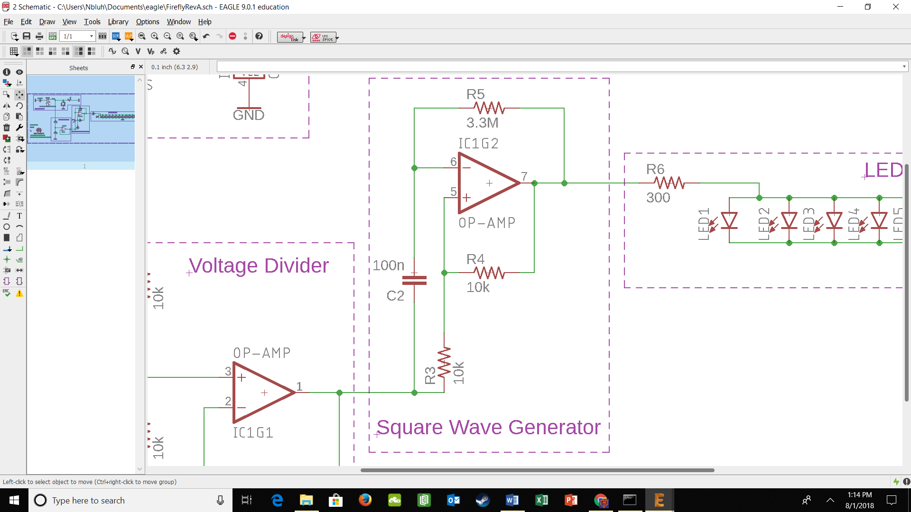

*Figure 5: Square Wave Generator.*

A square wave is ideal for turning the LED pattern on and off, as the square wave essentially has two states (in this case roughly 3.4V and 0V). This circuit generates a square wave by relying on the capacitor to charge and discharge. Once it is fully charged C2 will cyclically charge and discharge, the time this takes is characterized by the equation

$$τ=R*C$$

Where Tau is the time constant for charging and discharging. For more on RC time constants, check out <https://www.electronics-tutorials.ws/rc/rc_1.htmlf> . The voltage across the capacitor (and the inverting input of the op-amp) varies with time as seen in figure 5. The voltage across R3 on the other hand is constant, as is its contribution to the non-inverting pin of the op-amp. It is here that we rely on op-amp behavior to create the square wave. By connecting the output of the op-amp to its own non-inverting input with R4, the op-amp strives to maintain an equal voltage at both inputs. As the voltage of inverting input is cyclically changing, this requires a cyclic change in the output of the op-amp to maintain equal voltage inputs, this is where we get out square wave (seen in figure 6).

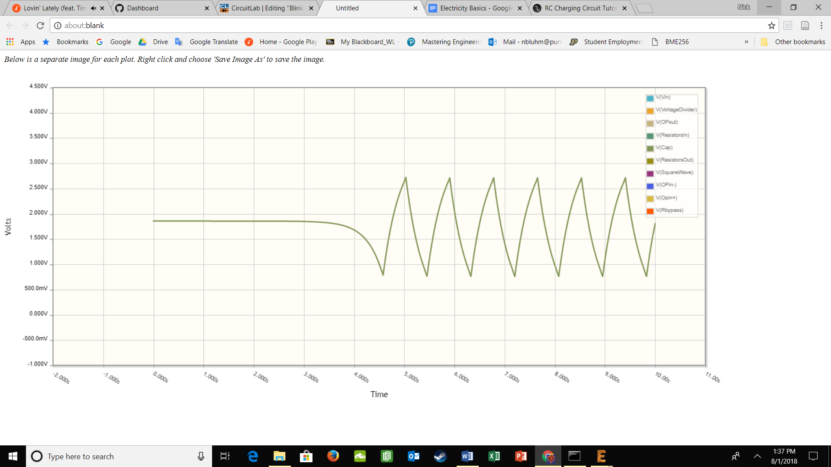

*Figure 6: Voltage across C2.*

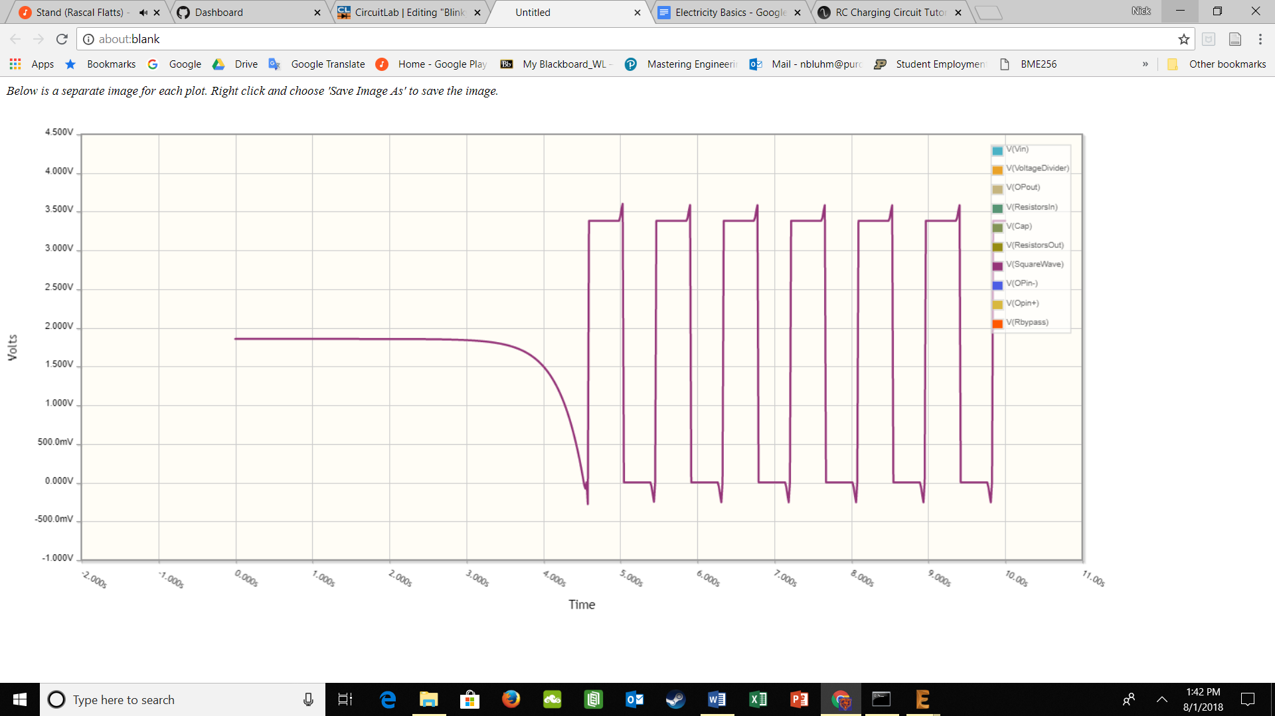

*Figure 7: Voltage output from the op-amp.*

***Testing***

1. Assemble the circuit as shown in the circuit diagram
2. Use the oscilloscope to view the voltage from C2 and the op-amp
3. Verify that those outputs match with the above images

**Part #4: LED Pattern**

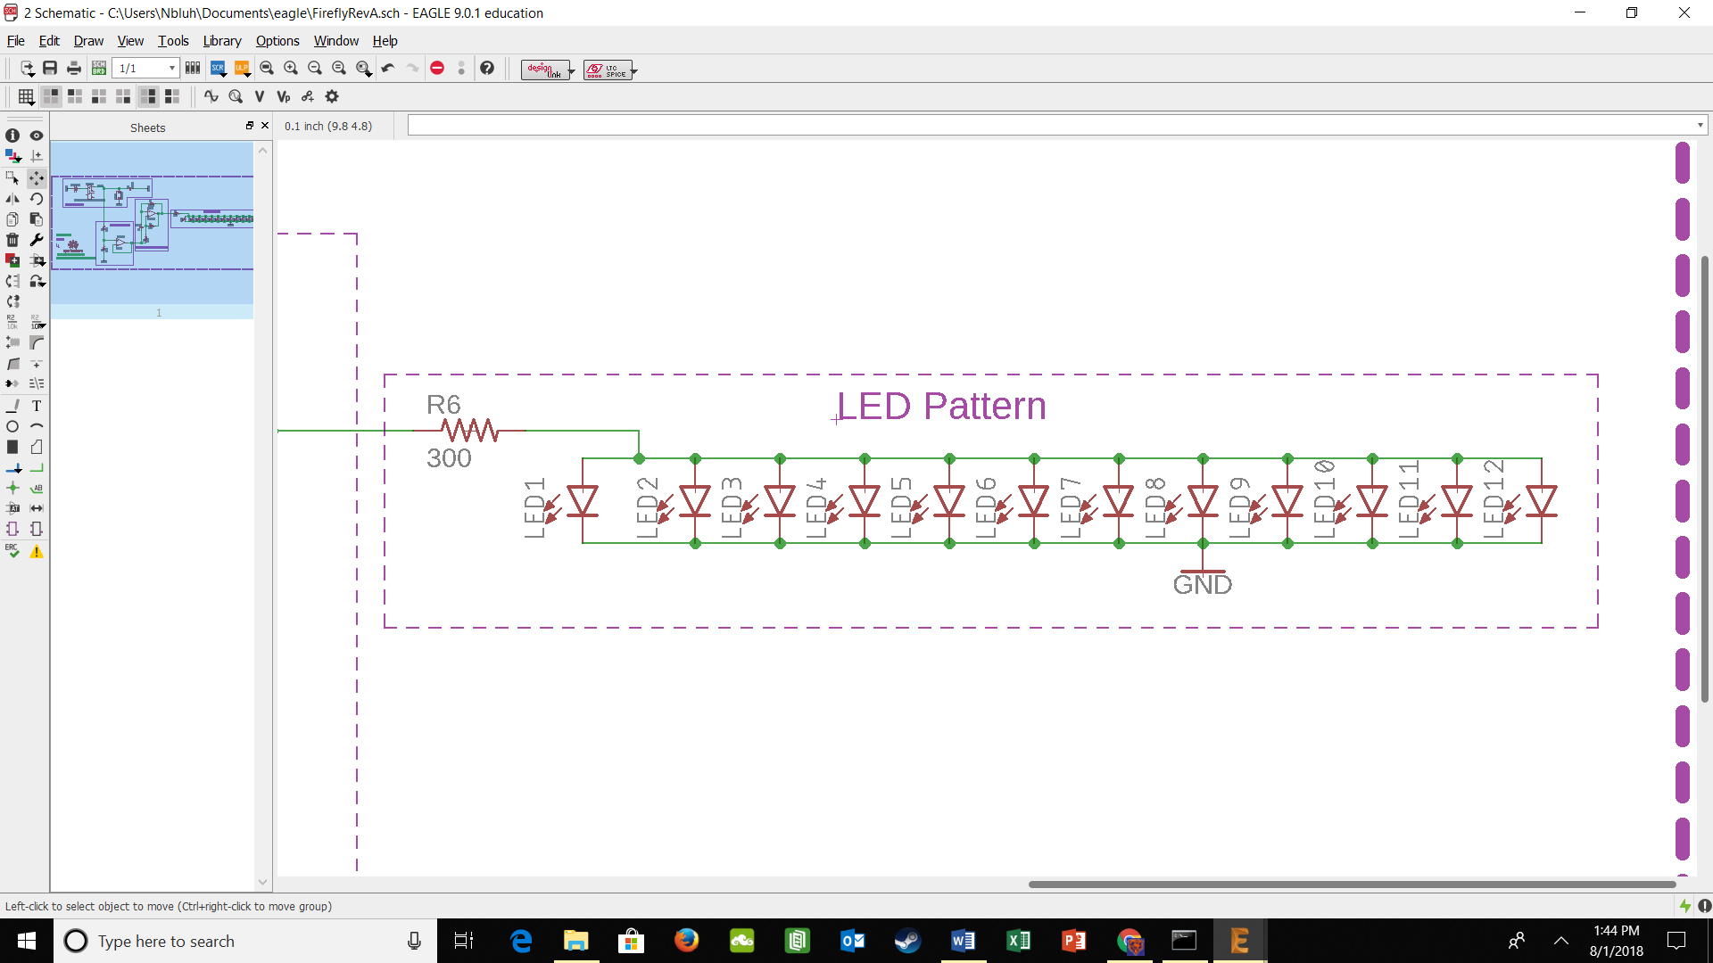

*Figure 8: LED Pattern*

To power the LED pattern and turn it on and off, we simply use the square wave generated in the previous part. We use R6 to set the current going to the LEDs, in this case setting the current to roughly 1 milliamp. Take notice that all the LEDs are connected in parallel so that they have the same voltage and will therefor turn on and off at the same time, with the same brightness.

***Testing***

1. Assemble the circuit as shown in the circuit diagram
2. Verify that the LEDs turn on and off roughly once a second

**Part #5: Soldering the PCB**

Now that you understand how the circuit functions, solder the PCB together using the provided components and board. The schematics below may be beneficial.

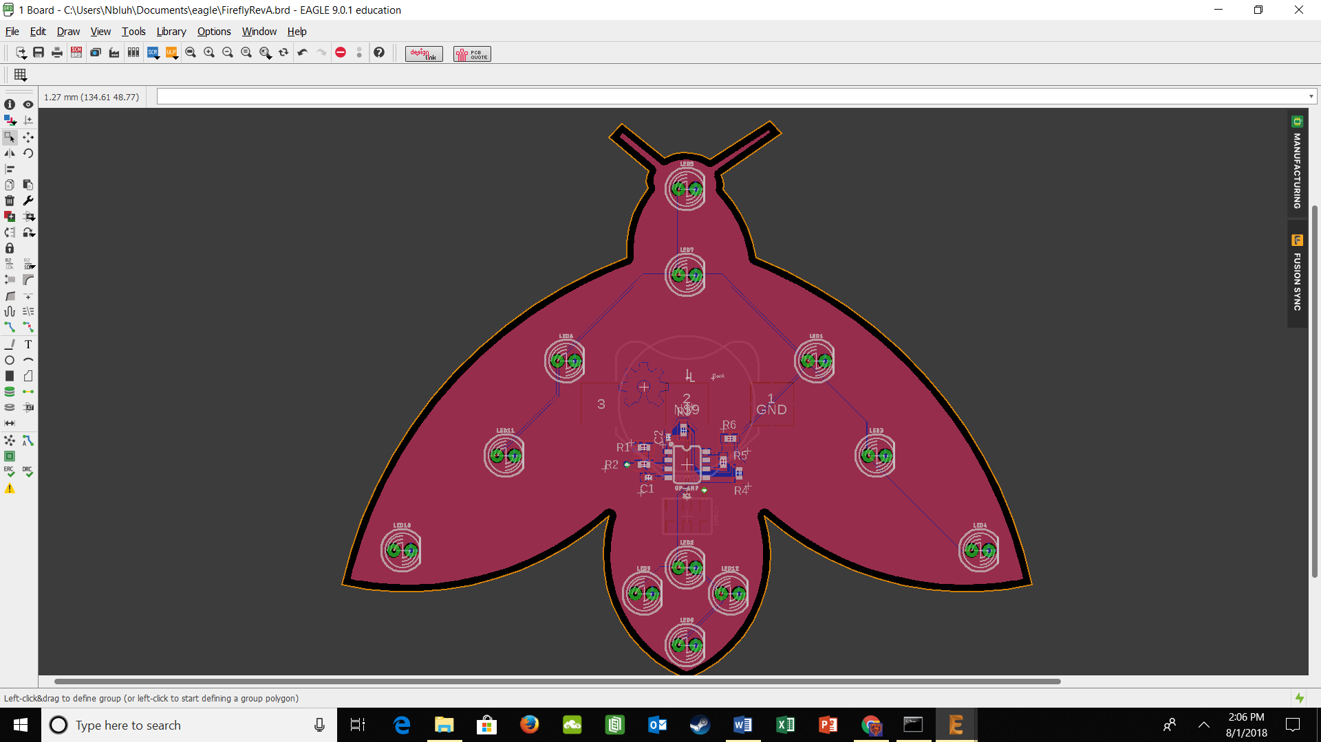

*Figure 9: Top view of Firefly PCB*

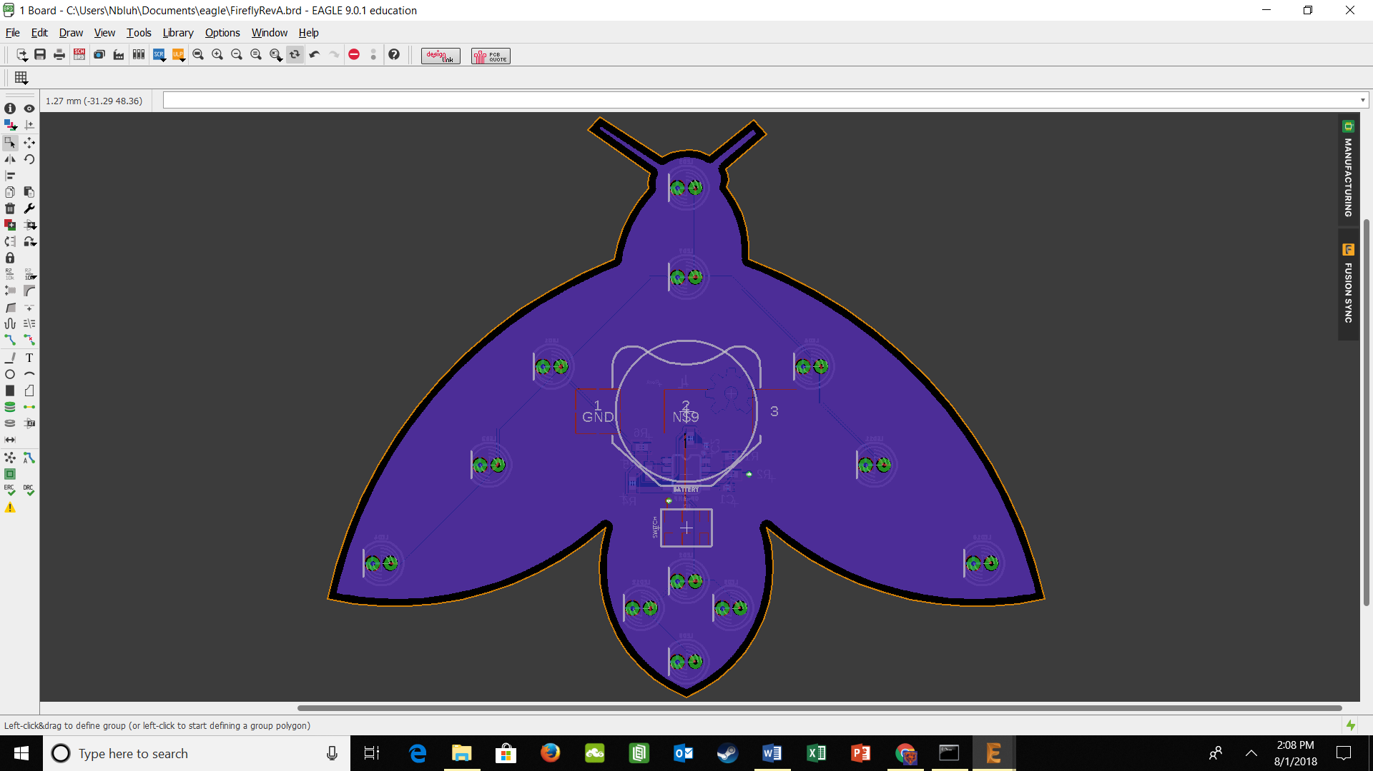

*Figure 10: Bottom view of Firefly PCB*

**Revision History**

|  |  |  |
| --- | --- | --- |
| **Revision Code** | **Revision**  **Date** | **Description** |
| A | 8/1/2018 | * Initial document for second year of #FunTimesWithTheTA |